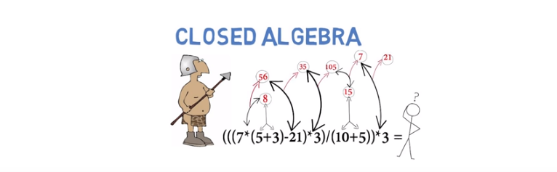
The above figure: the algebra is said to be closed because each time you do an operation on these rational number, you get a rational number back, the same type as the operands you started out with. That's what a closed algebra is.

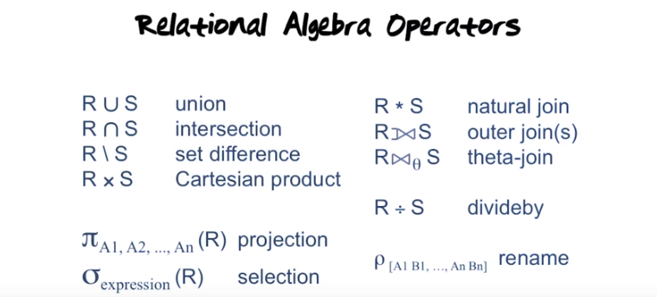
Projection operator: you can think of as eliminating columns from a result. The selection operator: you can think of as eliminating rows. 符號的記憶: π即pi, 跟projection首字母相同; σ即sigma, 跟selection首字母相同.

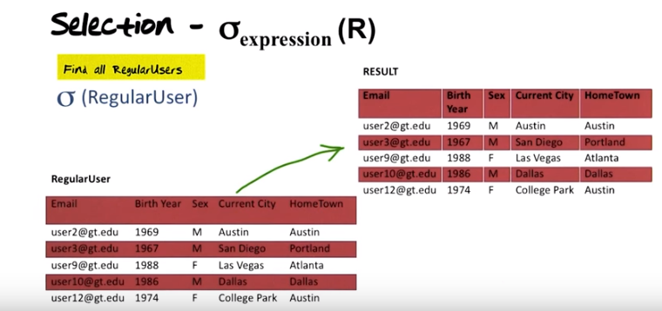
上圖: σ_expression (R) 中的expression即選擇的要求, 若無expression, 則表示所有的都選, 比如上圖中的例子.

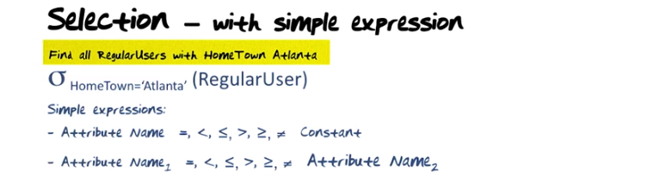

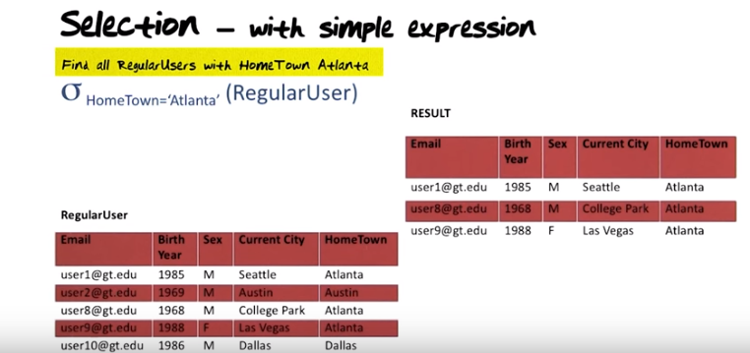
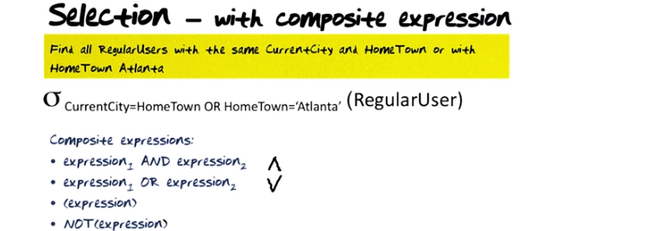
^叫做conjunction, V叫做disjunction. (expression)表示判斷expression 是否為true. Think of Java.

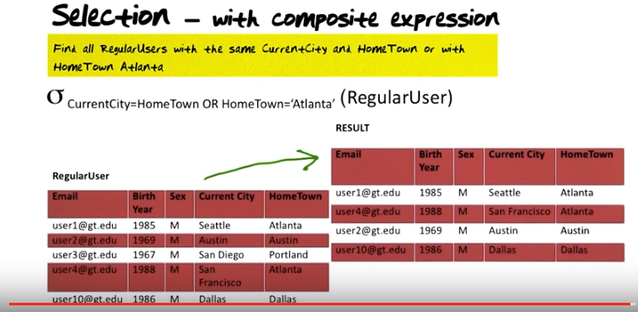

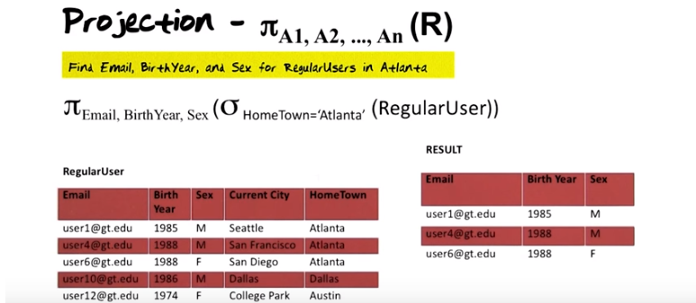
The above figure: what I talked about earlier that relational algebra is a closed query language, because what actually happends here is that this query here is done in two steps when we formulated. First, we take RegularUser and do a selection from it with the selecction condition, and then from the result of that which we know is a relation. We then do the projection on that. So this is a composite query using two operators and this can only be done when your algebra is closed.

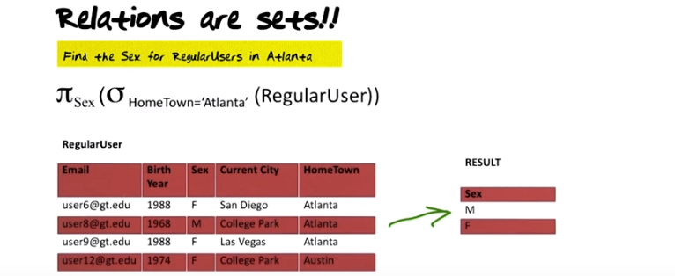
The above figure: RegularUser中有兩個F滿足要求(Hometown='Atlanta'), 但RESULT中只有一個F. 這是因為relations are sets (think of Java中的Set, 沒有重復的元素). And again, relation algebra is a closed query language. You start with a relation, you end with a relation. Relation is a set, therefore you only have two rows: male and female. 由此可知, σ和π弄出來的都是relation.

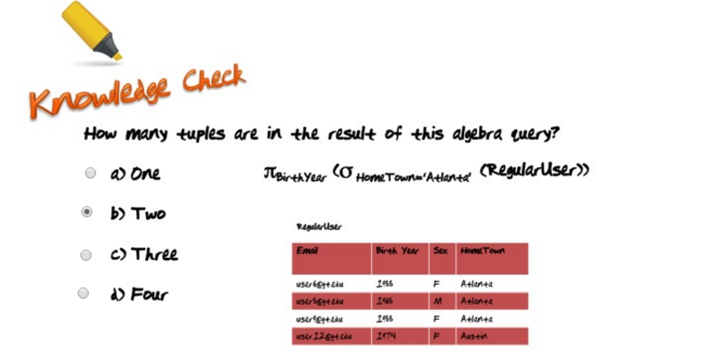
The above figure: the Birth Year in each row are: 1966, 1966, 1966, 1974.

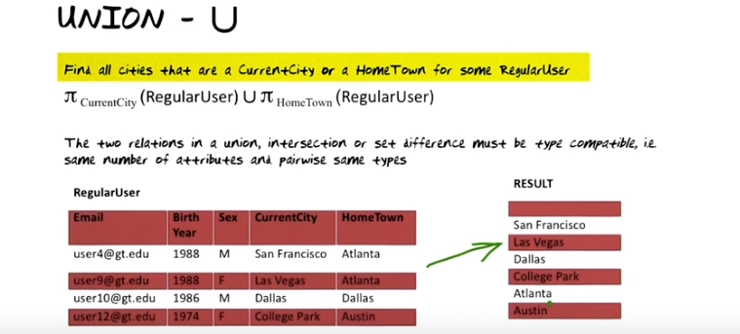


上圖中那句type compatible的意思是指: U兩邊的relations要有相同數量的attributes. 注意上例中, U兩邊的relations是projection之後的, 它們都只有一個attribute(即CurrentCity或HomeTown). 另外, pairwise same types的意思是指U兩邊的relations的attributes配對後的type要相同, 如CurrentCity和HomeTown都是varchar 50.

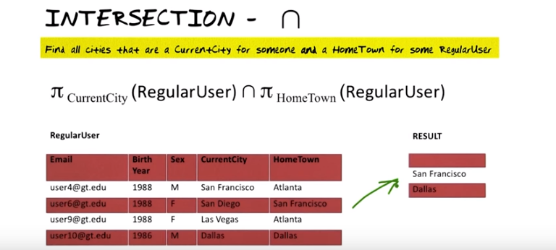
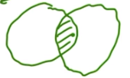

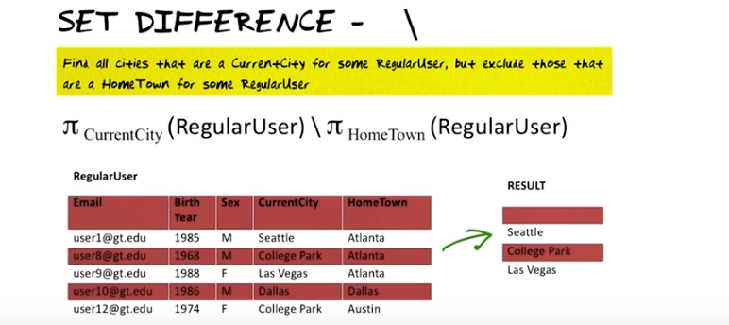


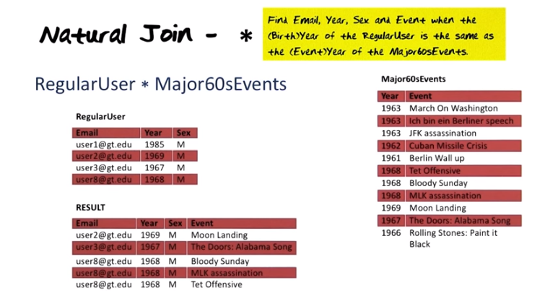

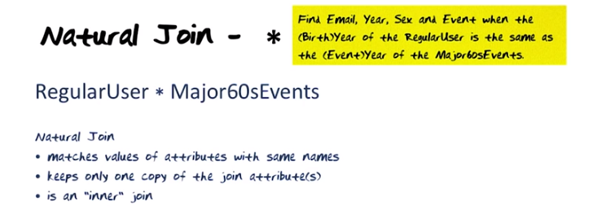
The above figure: it's called an inner join because only the tuples that actually appear in the relation and match will appear in the result. Those that had no matches will not appear in the result. “Keeps only one copy of the join attributes”意思是結果中只有一列是Year, 而不是兩列Year. 這可以和下下圖中Theta Join中的”all attributes are preserved”相對比. 注意上上圖中RESULT中沒有user1, 但有三個user8.

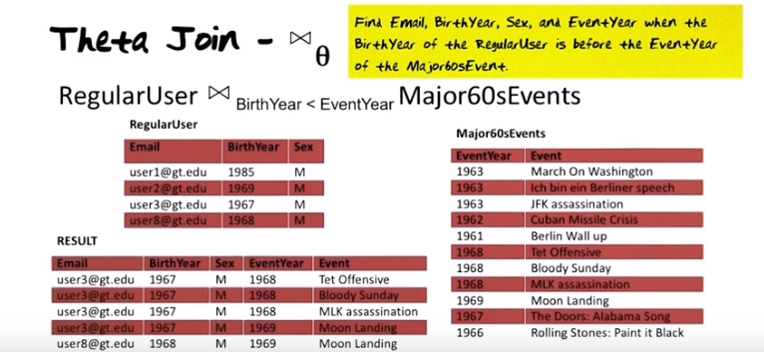
In contrast to the natural join, in this case the two join attributes have different names. With the natural join, they had the same name. Also in contrast to the natural join, both of the join attributes will appear in the result: BirthYear appears and EventYear appears.

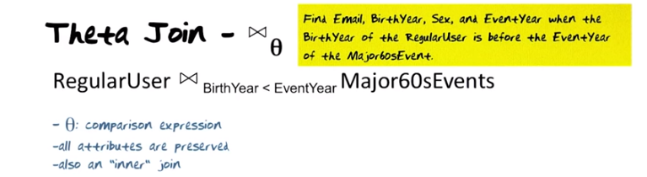

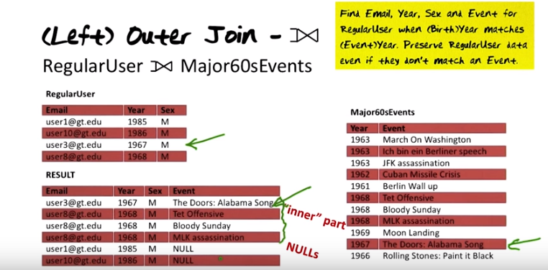
The above figure: RESULT中的user1和user10是outer part. 注意是只將left operand(即RegularUser)中的沒match到的弄到outer part中去了, right operand中的沒管, 所以叫left outer join (M.O.)

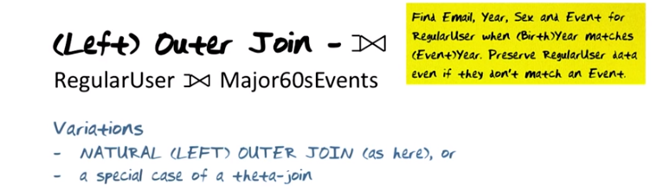

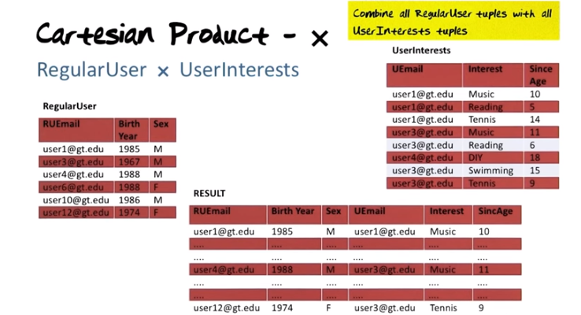
上圖: Cartesian Product就相當於群論中的直乘. RegularUser中的每一行都跟UserInterest中的所有行組成一個新行.
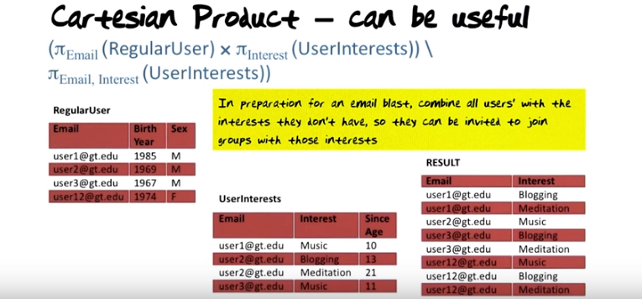

上圖: blast: 一陣風,爆炸,此處應該是群發郵件的意思. π_{Email, Interest} (UserInterests)意思是在UserInterest中將Email和Interest之外的所有列都刪掉, 即只留下Email和Interest兩列. () \ ()整個表達式的意思就是從Cartesian Product結果中去掉UserInterest表中已有的{Email, Interest}組合. 另外注意Cartesian Product結果中也只有一列Email.
Notice that the two operands in the substraction are type compatible in this case here, because you have Email × Interest, and you substract from that email and interest.

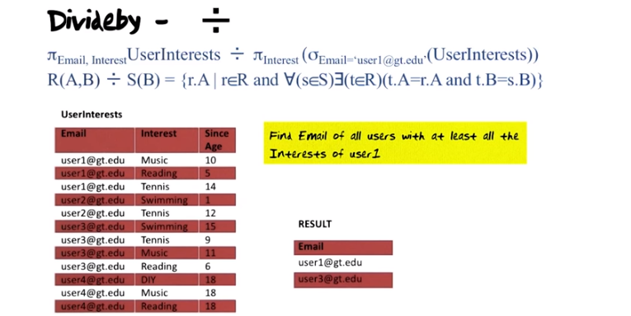
÷右邊的operand括號中總是右邊operand的第二個attribute(即B)

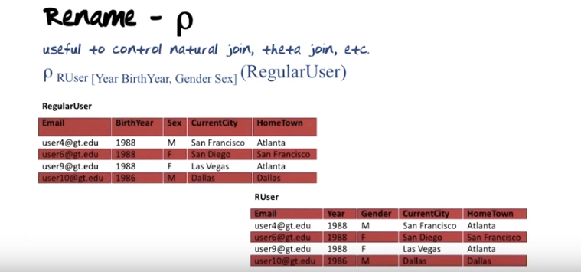
上圖中的ρ那個式子的意思即將BirthYear改名為Year, Sex改名為Gender, 改後的表的名字也從RegularUser改為RUser.

The above figure (沒錯, 上圖就只有Relational Calculus兩個單詞): the two fundamental formalisms for relational database query languages: relational algebra and relational calculus (不只是calculus, 而是relational calculus). To distinguish between the two, relational algebra is procedural in nature, it's operator based and basically what you do is you say take this relation, …. , so you are basically describing step by step what you're supposed to do to get to the result. Calculus, in comparison, is declared to be in nature. Instead of saying what to do step by step, you simply describe the result that you want. So it may appear that it's a higher-level language with more expressive power. As it turns out, the algebra and calculus were defined in such a manner that with respet to data retrieval horsepower, they can actually be shown to be equivalent. SQL is mostly based on tuple calculus.

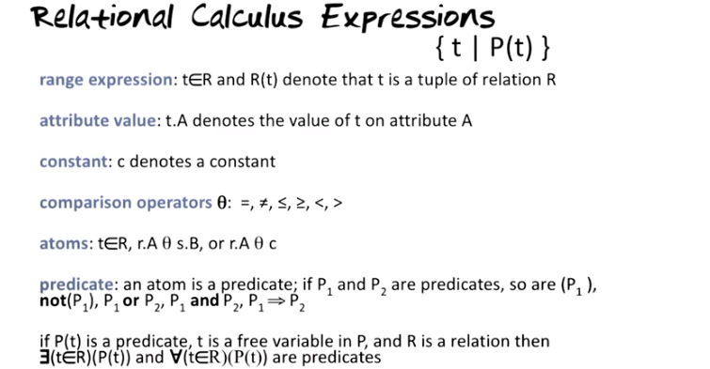
上圖中的(P1)表示判斷P1是否為true.

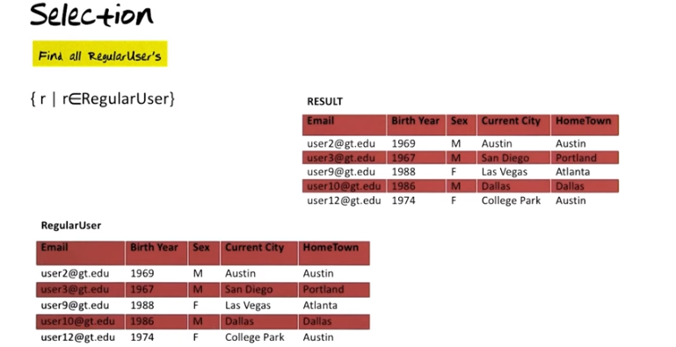
The above figure: now let's take a look at the first very very simple operation expressed in tuple calculus, namely that of selection.

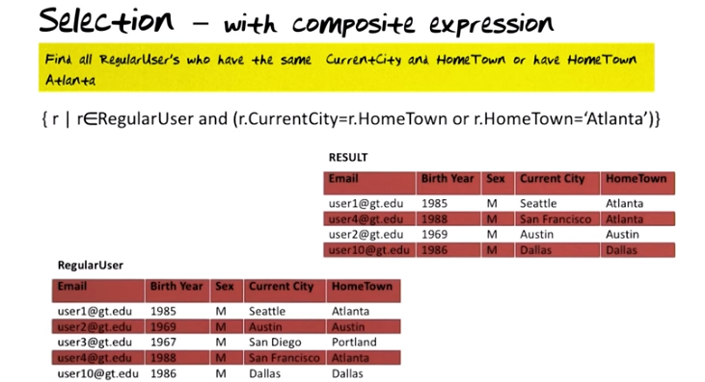

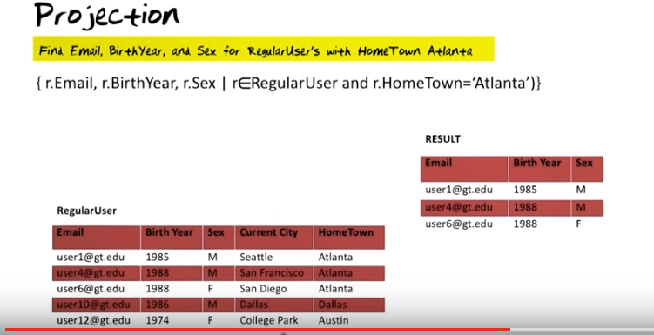
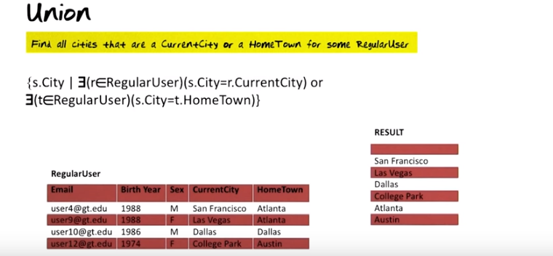
上圖的s.City的那個表達式看起來複雜, 其實很簡單. 不用管s是甚麼, 把s.City理解為一個city就可以了, 這個city可不斷地變, 直到存在一個r, 使得它的r.CurrentCity等於這個city(即s.City), 這個city就是一個CurrentCity, 即就是我們想要的.

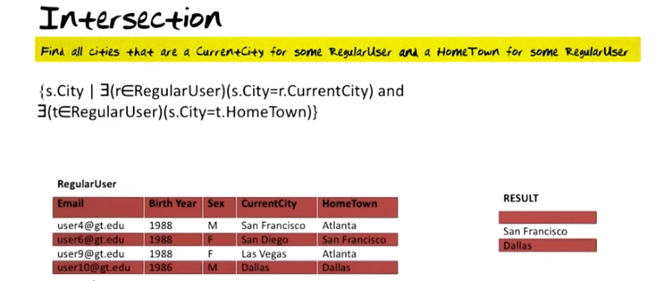

上圖中的那句黃話: Find all cities that are a CurrentCity for some RegularUser and a HomeTown for some RegularUser. 其中的some RegularUser 和some RegularUser 可以是不同的RegularUser. 上圖中的表達式跟上上圖(Union)中的表達式唯一的區別就是or換成了and.

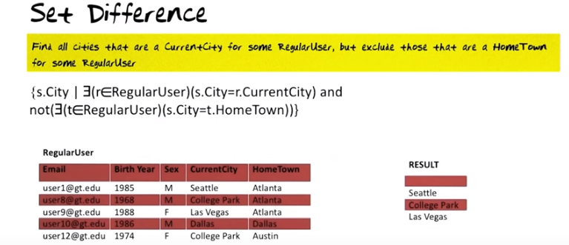
上圖中的表達式跟上上圖(Intersection)中的表達式唯一的區別就是多了個not.

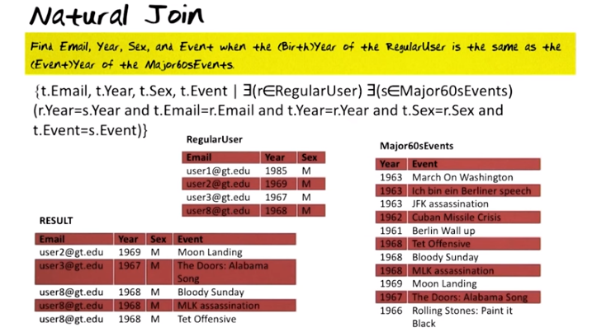
上圖的表達式看起來複雜, 其實也很簡單. 表達式第二中重要的是r.Year = s.Year這一項, 因為它是join的要求條件. 剩下的都是賦值, 如t.Email = r.Email表示t.Email取r.Email的值, t.Event = s.Event表示t.Event最s.Event的值(用s是因為只有s中才有Event, s是Major60sEvents中的一行).

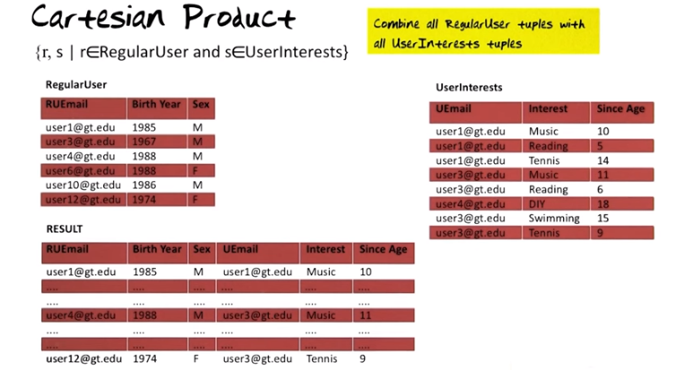

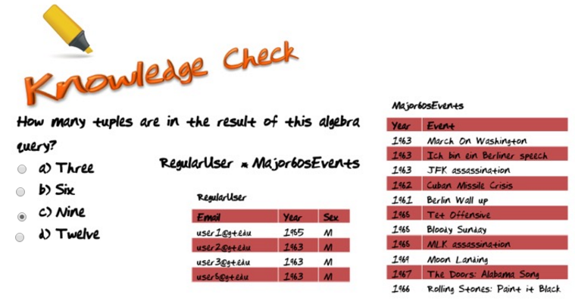
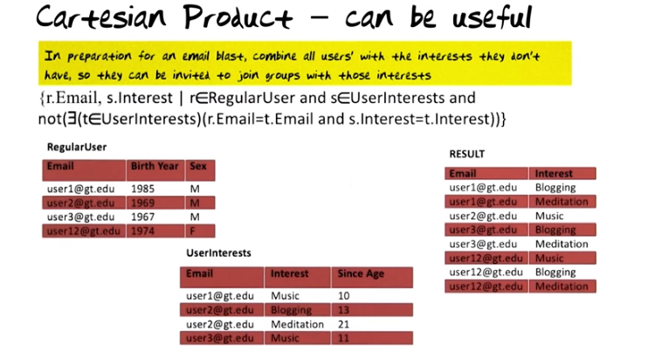
上圖表達式中的and之前的那段就是cartesian product的表達式, and之後的也很好理解.

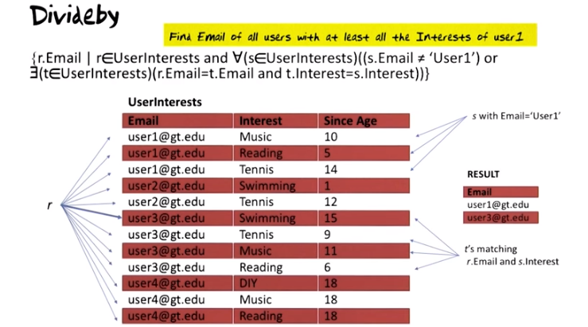
上圖表達式之理解: 主要是看or的兩個operand. or之後的那段其實暗含了s.Email = 'User1'這個要求. 至於or之前那段 為何當s.Email != 'User1'時沒通過or, 還沒想清楚. Textbook p210有解釋.
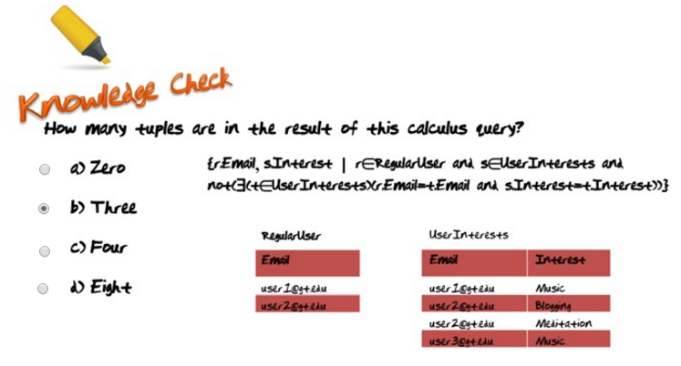
上題中的表達式其實就是Cartesian Product – can be useful中的表達式, 即自己沒有的興趣. 那三個tuple為:
user1@gt.edu Blogging
user1@gt.edu Meditation
user2@gt.edu Music

之所以無
user3@gt.edu Blogging
user3@gt.edu Meditation
是因為user3不在RegularUser中

